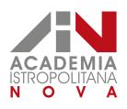 | MOVED - DESIGNING MODERN ADULT EDUCATION POLICY  Modern adult education policies for regions and cities
MOVED Policy Brief  ISBN: 978-80-99976-03-1  June 2020 | Marta Jendeková, Ivana Studená a Zuzana Štefániková

EUROPEAN
POLICYbrief

Introduction

This document offers an overview of the results of the applied research project MOVED – Designing Modern Adult Education Policy (further MOVED). The aim of the MOVED project was:
- to map activities in the field of adult education (further AE) at the level of local governments, specifically at the level of regions and cities
- to increase the awareness of regional policy makers about the functions and benefits of adult education activities for the region, employers but also for the final beneficiaries - citizens
- to support the institutional capacity of public administration at regional level
- to contribute to the development of an effective public policy for adult education at all levels with an emphasis on regional self-governance structure.

The MOVED project responded to the need to raise awareness about the needs and functions of adult learning in the context of lifelong learning. At the same time, it is topical and extremely important to look for solutions to increase the participation of adults in learning activities. How we will cope with new challenges in working, civic and personal life is closely linked to our ability and willingness to learn and improve skills throughout life. However, according to statistics, the participation of adults in learning is relatively low in Slovakia - in 2019 we reported 3.6% (4.0% in 2018), while the EU average is just over 10% while the Scandinavian countries reach up to 30%.

The discussion on adult education in Slovakia is complicated by unsettled terminology. The expert community dealing with this topic has long pointed out the need to clarify the definition of adult education. In Slovakia, we do not have a legal concept of adult education. Its content is partially replaced by the term “further education” defined in Act no. 568/2009 Coll. on lifelong learning as follows:
"Further education is education in educational institutions of further education (hereinafter referred to as "educational institution") following upon the school education or other education that follows upon school education. Further education makes it possible to acquire a partial or full qualification or to supplement, renew, extend or deepen the qualification acquired in school education, or to satisfy interests and acquire the capacity to participate in the life of civic society. Successful completion of further education does not lead to a degree."

The Council of the EU defines adult education as "the entire range of formal, non-formal and informal learning activities, both general and vocational, undertaken by adults after leaving initial education and training.“ Thus, the term AE includes adult education within the school system (formal education at primary and secondary schools and universities), in various organized courses or seminars (non-formal education), but even unconsciously in everyday life, for example by watching television, using the Internet and so on (informal learning). For the purposes of the project, we used the term adult education in the sense of the above stated definition of the Council of the EU.

Analysis and results

The key activity of the project was to monitor the situation in AE in Slovakia and to compare the findings with information from selected EU member states (Slovenia and Estonia). Monitoring of public adult education policies took place at 3 levels: (i) activities of public institutions, (ii) activities of social and economic partners and (iii) activities of private and non-governmental organizations.

Data collection, methodology.
Semi-structured interviews were used to gather information, which thematically focused on a) strategies and planning of AE activities, b) cooperation and experience of an organisation in the field of AE, c) quality aspects and d) awareness of the benefits and impacts of AE. The interviews were conducted at the departments of education as well as of strategic planning in all eight regional authorities and in selected cities (Trnava, Trenčín, Hlohovec, Liptovský Mikuláš, Zvolen, Prešov, Trebišov). A questionnaire was also used for data collection, that focused on collecting information on a) strategies in providing AE by Further Education Centres at universities and Universities of the Third Age, b) providing AE at secondary schools, c) AE provided by training institutions from the private and public sector, NGOs, in museums and libraries. During the project, we also concluded 13 multisectoral partnerships with organizations throughout Slovakia. The aim of these partnerships was to ensure a comprehensive overview of AE and the effective implementation of the project, as well as the use of findings after the end of the project and the sustainability of outputs.

In terms of different levels of the AE ecosystem, we monitored two levels:

Horizontal level of the AE ecosystem. During the three phases of project activities, we mapped the current institutional background of the provision and thus the creation of the offer of adult education. We mapped how the primary, secondary and higher education institutions, private and public educational institutions, including NGOs, employers, Labour Offices and cultural and educational facilities, provide adult education activities.

Vertical level of the AE ecosystem. In terms of different levels of public administration, we mapped strategic documents in the field of lifelong learning and adult education policies at the national level, which in Slovakia define the regulatory framework for the provision of AE. We mapped how these regulatory frameworks are put into practice, especially through the competencies and activities of self-governments, while in our project we focused on regions and cities.

Motivation for adult participation in education. The need and decision to learn is related to understanding the benefits of education. It is the communication about the benefits of AE that is an important condition for increasing the interest in AE and learning in the regions. It is important and helpful to perceive the benefits of AE in terms of economic and non-economic benefits. For simplification, we present three levels of AE beneficiaries - individual participants, employers and society.
The benefits for individual learners are
- economic: higher income, employability in a lifelong perspective, better career prospects
- other: improved quality of life and health, higher participation in community life and civic activities, success in personal and family life
The benefits for employers are
- economic: profit, competitiveness, production, innovation capacity
- other: corporate culture, workforce development and stability, employee motivation
The benefits for community and society are
- economic: higher GDP and competitiveness, human capital
- other: sustainable development and the environment, reduced inequalities, social cohesion, civic society, well being of the population.

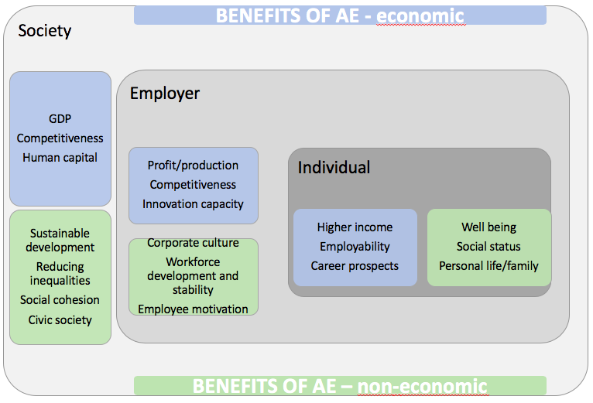

Support for the participation of adult individuals in education in Slovakia. No financial resources are earmarked for the education of adults in the state budget. Some support for adult education from public sources is available, for example, through active labour market policies under the Employment Act. Educational activities for adults are also realised within the support of various programs, e.g. in further education (Operational Program Human Resources), regional development (Integrated Regional Operational Programme), culture (Fund for Support of Art), support for entrepreneurs (OP R&D), farmers (Rural Development Programme), etc. ESIF and programs managed by the European Commission's EACEA agency (Erasmus +, Creative Europe, Europe for Citizens) are widely used to support AE programs for students, volunteers, citizens, youth and adults. Municipalities support various cultural, social, sport or environmental activities, which are often of an educational nature and include adults. According to international statistics, the highest portion of learning by adults is realized at the workplace and that is true for Slovakia as well as for other EU countries. In general, adults learn mostly in connection with employment. However, despite the high share of training provided by employers, in Slovakia a significant part of such training is associated with compulsory training activities (e.g. occupational safety and health) or job-specific training, which may not contribute to skills development.

Impacts and recommendations

The results of the project are in line with the EU's strategic position in the field of education, namely that education must be understood in all its width and depth, and that lifelong learning - from the cradle to the grave - must be promoted. We propose to systematically use the term "adult education" and its definition according to the Council of the EU, as "the entire range of formal, non-formal and informal learning activities, both general and vocational, undertaken by adults after leaving initial education and training“.

- We consider the following three factors to be the basic attributes of achieving social change in the culture of adult education. Adult education must be
a. Systematic - this is a key condition for achieving lasting and positive results.
b. Accessible - citizens must have access to information on training opportunities and basic support in choosing or completing their education, regardless of their social or economic situation.
c. Ensuring provision quality - the education provided must meet at least the minimum quality standards that need to be observed in practice.
- At the national level, we recommend harmonizing terminology; it would be optimal to harmonize the national and EU terminology in the new law on adult education. We propose to adopt the adult education definition of the Council of the EU.
- We consider it crucial that a lifelong learning policy be put into practice, resulting in a change in the attitude of both policy-makers and key players in the regions to promote adult participation in learning. Education policies must not end with the education linked to compulsory schooling or higher education, but must also cover the entire period of adulthood. When we talk about education, we need to think consistently about formal, non-formal and informal ways of learning.
- Education is seldom a priority theme for territorial development. However, it should be noted that education often paves the way to other topics, and is important in relation to other topics - e.g. we will probably not achieve a high level of waste separation without an awareness raising campaign and explanation of its importance, and thus education, especially for adults.
- Strategic documents are effective governance tools for adult education also at the regional governance level. We recommend that the topic of adult education is integrated in the regional strategies. At the regional level, national strategic objectives in the field of AE should be reflected in all strategic documents, e.g. in the Regional Strategy for Education in Secondary Schools, in the Strategy for Regional Development, in the Plans for Economic and Social Development, etc.
- For the implementation of AE activities, it is necessary to ensure a suitable legal environment and make changes if necessary, so that local governments can pursue the goals of national strategic plans.
- We recommend creating opportunities for continuous vertical communication and cooperation of the national level and local governments, especially at the level of regions and cities in the field of AE. A good example could be initiatives in the area of quality assurance and monitoring of non-formal AE in practice, which would be supported by the national level in cooperation with local governments.
- At the regional level, we recommend supporting the cooperation of AE actors (local governments, AE providers, employers, labour offices, secondary and higher education institutions, etc.) that could support sharing information about the AE provision, including the information about i) providers and participants in adult education activities, ii) forms of AE provision and other relevant topics. Creating and sharing information base about AE is important for making any strategic decisions about AE.
- From our point of view, local governments have all the necessary competencies in the area of AE, whether it is described in law as “creating conditions for further education”, or within the general “care for the well-being of citizens”. We are primarily concerned with non-formal education, so there is no need for legislative changes in the field of education. We also draw the attention of local governments to civic education, which often remains outside the scope of interest and is random rather than systematic.
- We recommend local governments to exchange experience in cooperation with other local governments, as well as at the international level, and to participate in international projects. The infrastructure in the field of AE exists, local governments even cover many activities in this area, however, it is necessary to obtain an overview of the situation, especially about individual actors, and subsequently effectively coordinate and support AE activities.

Project identity
Project title | Designing Modern Policy on Adult Education  (MOVED)
Coordinator | Academia Istropolitana Nova, civic association (AINova)  Zuzana Štefániková, Marta Jendeková
Project team | The project was implemented by AINova experts in co-operation with external experts from the Slovak Ministry of Education, State Institute of Vocational Training, Asociation of Institutes of Adult Education, Association of Career Counselling, Association of Cultural and Awareness-raising Institutions, Regional awareness raising centre in Nitra, University in Banská Bystrica, UNiversity in Prešov, Centre of Social and Psychological Sciences / Slovak Academy of Sciences, Centre of Further Education at the University of Žilina, School of Economics and Management of Public Administration in Bratislava, Education Academy of Jan Amos Comenius, towns of Trebišov and Hlohovec, foreign partners from EAEA, Slovenia and Estonia.
Programme | ESF – Operational Programme Effective Public Administration, nr Z314011K061
Duration | 1.5.2018 – 30.6.2020
Budget | 269 000 EUR
Web | www.ainova.sk/project/tvorime-modernu-politiku-vzdelavania-dospelych
Contact | marta.jendekova@ainova.sk
Other sources | Relevant outputs of the MOVED project  ● Monitoring of public policy of adult education in Slovakia (Report from the 1st phase of the project)  ● Evaluation of public policy of adult education in Slovakia (Report from the 2nd phase of the project)  ● Recommendations for public policy of adult education in Slovakia (Report from the 3rd phase of the project)  ● Recommendations for public adult education policy: A handbook for local governments

